UI reqirement gathering process

* Requirements Engineering
* why – what – how (gather organize represent)
* ethnography
* what is success, real-world constraints, user characteristics, task decomposition, environment
* real-world constraints
  + ttd – time to develop
  + cost, size, power, consistency, backward compatibility
  + you have to be different

Task analysis

Interface evaluation (existing and prototype)

3 key components in considering how people work:

* activities
* artifacts
* relations

Task analysis methods:

* ethnography
  + contextual inquiry: asking questions
  + field study
  + observational study
* observation
* cooperative evaluation
* interviews (record)
* questionnaires
* focus groups
* study documentation
* look at competitive products

determine data you need to gather using various appropriate methods

represent tasks and subtasks

use data to improve design

Interview steps:

* preparation
* field study
* analysis
* reporting

affinity diagram – similar things are grouped

types of findings

* qualitative
  + observe trends, habits, patterns
* quantitative

ask to think out loud user doing activity

or just cooperative evaluation, ask each other questions, more relaxed

INTERVIEWS

structured – unstructured – semistructured (start with focused, move to open-ended discussion)

What else should I have asked you?

QUESTIONNAIRE

Seven point likert (use odd numbers)

FOCUS GROUPS

group of individuals 3 to 10

**representing data**

use-case: user intention + system responsibility to that intention

user characteristics+persona: description of user and what user wishes to do

task outlines: good for sequential tasks, detailed

narratives: describe tasks in sentences, paragraph

hierarchies & networks: decomposition of goals and tasks

* hierarchical task analysis (HTA)
  + graphical notation & decomposition of tasks
  + sequential and hierarchical
* network / er diagram
  + object, relation, actions on objects

flow charts

* workflow: flowchart of documents in instutition, not software

HTA HTA HTA HTA HTA HTA HTA HTA HTA HTA HTA HTA HTA HTA HTA HTA HTA HTA HTA HTA HTA

**INTERFACE EVALUATION**

Determine if our design is good or bad

design evaluation, implementation evaluation

good 🡪 scientifically prove

heuristic evaluation

* method for reviewing usability principles

user testing

* on field or on lab
  + lab 🡪 one way mirror or record
  + field 🡪 collaborative work can be done, get permission record are difficult

utility: functionality of the system

system evaluation:

* process of gathering info about the quality of system
* measure these:
  + functionality
  + usability
  + maintainability
  + reliability
  + portability

**Hawthorn Effect**

users like to please the evaluator

**Cognitive Walk Through**

bring psychology theory into informal and subjective walk through

Go through description

list of actions the user makes to perform the task

**Heuristic Evaluation**

can be used both for design and implementation

evaluator needs to have knowledge, carry out evaluation independent and combine results and suggest fix, rate 0 to 4, discuss with design team

**Review Based Evaluation**

more free format, experimental psychology

discussing, criticize

**Empirical Evaluation**

concentrate on end users rather than experts

controlled experiment

independent(we are changing)-dependent(measured) variables

good for individual decisions

You have to have a hypothesis.

experimental design: between groups / within groups

* between: different subjects assigned to different groups
  + group differences should be considered
* within: subject performs in all conditions
  + more focused
  + everybody does everything

**Evaluation during active use**

acceptance testing: after 1 hour, receptionist will be able to enter data. verifies requirements are met.

field testing: user performs informal tests

user feedback:

* interviews and focus group discussions
* continuous user performance through data logging
* online trouble reporting

**execution evaluation cycle**

Computer is doing presentation, human does observation and articulation, system makes performance (execution plan)

**Prototyping**

cheap, non-working mockups

less effort

experiment with alternatives

**rapid interface prototyping**

prototype becomes product

rapid prototype:

* start with sketch of interface, visualize functionalities
* user-centered design: create, evaluate, refine

design rationale:

* during elaboration, write down why several design choices were made to not forget relationship between the technical constraints and choice of object type and placement

horizontal approach: whole system is built at a high level, details later. most useful at early stages

vertical approach: specific part is built, incrementally until fully understood

breadth: fraction of the feature set represented by the prototype

depth: how deeply each feature is implemented

top down approach:

* analyzes the tasks to define a conceptual design and models the interface in increasing levels of detail
* A black text on a white background

  Description automatically generated

bottom up approach:

* trial-and-error method
* best guess of the interface is prototyped and evaluated, a new best guess is redesigned
* when functional requirements are not known
* do as you go

low fidelity: cheap, simplified mockup, to get general feedback

low cost, useful communication vehicle

high fidelity: prototype is close to final product

high functionality, fully interactive, feel of final product

look: appearance

feel: interaction

paper mockup 🡪 low fidelity

prototyping tools

* ease of use
* fast turn-around
* extensive control over prototype features
* data collection capabilities

executable prototypes

lifecycle support

team design

version control

**PAPER AND PENCIL PROTOTYPING**

mandatory in early stages of design

successful at discovering usability issues

interaction is natural

* pointing with a finger = mouse click

person simulates the computers operation

* simulate computer operation
* facilitator: present interface, encourage user to think aloud
* observer: keeps mouth shut, takes notes – can be replaced by camera

low fidelity in look, high fidelity in depth (person simulates the backend)

paper prototype is interactive, sketch is not

save time and cost

focus on big picture

everybody can draw

easy modification

early design

not bothered with details

more open to suggestions and improvement 🡪 because less finished

if works on paper, doesn’t mean work on computer

performance might not be same

**stages of paper prototyping**

concept design: possible approaches sketched, validities verified

interaction design: structure of ui must be set, use postits, affinity diagramming

screen design: paint or photoshop to create rough designs

screen testing: developer explains actions

we can verify conceptual model, functionality, navigation & task flow, terminology, screen contents

we cannot verify look, feel, response time, small changes notable on paper but not on screen, users don’t explore as much

**wizard of oz**

software simulation with a human in the loop to help

used to simulate future technology (speech recognition, artificial intelligence…)

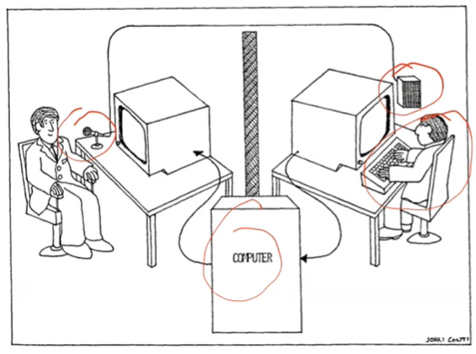

**facade tools**

used for gui prototypes

code is not reusable

balsamiq, figma, powerpoint, mockingbird, excel

**SITUATIONAL AWARENESS**

human control of complex dynamic (time changing) systems:

* control work
* operators
* examples

complex: many variables

human control: decision & action

systems perspective:

* high levels of performance requires that
* the technical system work well with the human operators
* within the constraints of the environment

**SITUATIONAL AWARENESS**

To always be “in control”, “in the loop”

key to good decision making and good performance

central to operations in which distributed warfighters must interact to make timecritical decisions in complex, uncertain environments

must get right info to right person at right time – in a form that rapidly understandable and usable

Definition: SA is perception of environmental elements wrt time and space, the comprehension of their meaning, and the projection of their status after some variable has changed, such as time.

It involves being aware of what is happening around you to understand how information, events, and your own actions will impact your goals and objectives, both now and in the near future.

3 parts:

* perception (see physically - observation)
  + observation
  + cause of sa errors mostly because of observation error
* comprehension (understand the significance of information – model)
  + what is going on
  + model
* projection (simulation - prediction – evaluation of actions)
  + what will happen
  + dynamic information and model
  + ability to project the future actions of the elements in the environment

SA demons

* attentional tunneling – focus one area
* requisite memory trap
* workload, fatigue & other stressors – psychological stress
* misplaced salience – incorrect priority
* complexity creep
* errant mental models – elevator buttons
* out of the loop syndrome – not known what to do when automation fails

information gap: data produced-information needed

find necessary information only

reason is gathering data from different systems sources

integrate data and filter

in the workplace a staggering 80% of safety incidents are believed to be caused by human error. Human error is system error.

Two different approaches to control:

* control by exception
* control by awareness

an operator cannot work properly without SA

SA still critical for overseeing automation

intervening: problem with out of the loop performance errors

non-autonomous automatic – does what it is told to do

autonomous aautomatic – has its own plans

all automatic systems should be transparent (show what they are doing)

difficult to understand, predict automation

operators turn of the automatic system to be in control (irony)

operators need to be in full control, have high sa

show much and dynamic information

visualization must support

* development of mental models
* automation of actions
* pattern recognition

principles to provide sa

* organize information around goals
* support comprehension
* projection should be available
* global sa (general idea)
* main goal is needed to be preserved
* make critical cues visible

SAGAT

* stop the operation and ask questions

INFORMATION VISUALIZATION

visualize: to form a mental image or vision of

infovis: try to tell sth – largescale collections of nonnumerical information

scivis: extract additional information, try to find sth

infographics: visual representations of information, data, or knowledge. quick clear explanation

visual analytics: science of reasoning with visual information

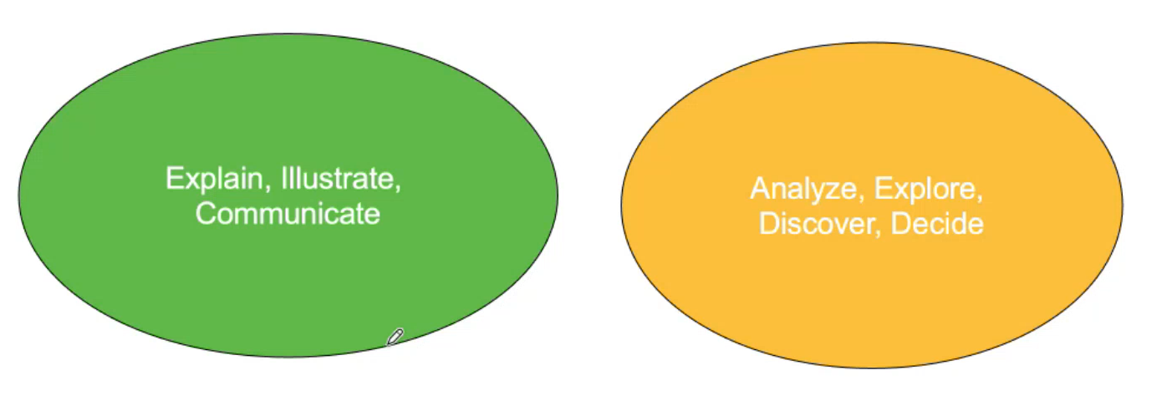

cognitive psychology: finding appropriate representation

data come very much, generating visual representation is important

3 challenges:

* computation and analysis
* theory and scholarship
* experiment and measurement

infovis helps

* communication
  + comprehension (amplifies coginition/understanding)
  + exploration and discovery
  + decision making (particularly use of filtering/dynamic queries)

visual representation more natural and efficient way to represent data or problem space.

rubber-band scale: change data as you want (political)

we build tools to amplify cognition.